Wild Rice Pilaf – It’s Wildly Delicious!

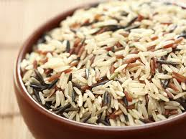

Ingredients:
1 Tablespoon olive oil -or- if you’re counting calories, its just as good if you use ½ tablespoon;
1 Tablespoon sodium-reduced soy sauce;
½ Tablespoon lemon juice;
2 sliced green onions;
¼ cup slivered and roasted almonds;
2 cups cooked wild rice blend.

Directions:
Cook the wild rice per package directions.
Roast almonds in pan on cooktop—watch careful so they don’t burn.
Whisk together the olive oil, soy sauce, and lemon juice.
Toss ingredients with the rice blend.
Add green onions and top off with almonds.

