Fresh Tomato Salsa
Servings: Six; Yields 2 cups
Ingredients:
2 fresh tomatoes, chopped
1 small red onion, minced
2 scallions, minced
1 clove garlic, minced
½ jalapeno Chile pepper, seeded and minced
3 Tablespoons chopped cilantro
3 Tablespoons fresh lime or lemon juice
Directions:
Mix all ingredients together and serve immediately or refrigerate in a tightly covered container.
Lasts up to three days.
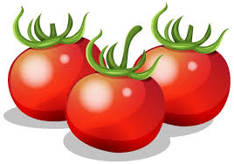
Tomatoes can be a valuable part of a healthy diet. Tomatoes are the major dietary source of the antioxidant lycopene, which has been linked to many health benefits, including reduced risk of heart disease and cancer.
The tomato (Solanum lycopersicum) is a fruit from the nightshade family native to South America. Despite botanically being a fruit, it’s generally eaten and prepared like a vegetable. They are a great source of vitamin C, potassium, folate, and vitamin K.

