PERFECT HAWAIIAN MEATBALLS FOR YOUR NEXT HOLIDAY BRUNCH
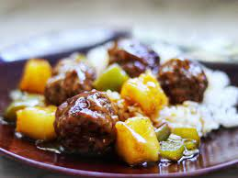

For the meatballs:
- 1-and-1/3-pound ground beef
- 2/3 cup breadcrumbs
- ½ cup minced onion
- 1 egg
- ¾ teaspoon ground ginger
- 1 Tablespoon oil
For your sauce:
- 2 Tablespoons cornstarch
- ½ cup brown sugar
- 1 can pineapple tidbits; juice drained and reserved
- 1/3 cup apple cider vinegar
- 1-2 Tablespoons soy sauce
- ½ cup chopped green pepper
Directions:
Mix the beef, breadcrumbs, onion, egg and ginger, and shape into 2-inch balls. Brown in oil over medium heat, about ten minutes. Remove meatballs from pan and set aside.
Mix cornstarch, brown sugar, pineapple juice, vinegar and soy sauce in the same pan. Bring to a simmer over low-medium heat, stirring until sauce thickens. Add the pineapple, green pepper and meatballs. Heat about 5 to 7 minutes (until meat reaches internal temperature of 160 degrees F).
Makes 16 servings.

