**August 2024 Writer’s Challenge**

*Sometimes you leave a place, but the place doesn’t leave you.*

*Ignite Your Imagination*

**

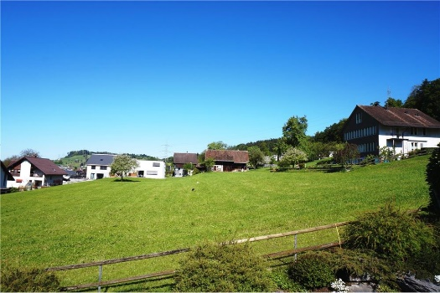

In 500-750 words, describe your primal landscape. No characters needed. If you prefer, you may populate the landscape with characters.

We are all highly influenced by the place of our youth. For better or for worse, we are all highly influenced by the place of our youth. Let yourself go through the intense experience of remembering this landscape, its weather, people, its joys and sorrows.

There are numerous primal landscapes on this planet. We live in dry and wet climates; we live on wind-swept hillsides or in the middle of traffic-choked cities. Small town life is unique, but so is urban, suburban, and rural life. All primal landscapes are interesting to the writer who lived there because the landscape is part of who he or she is.

Your childhood landscape is in your DNA. You grew up listening to the accents, attending gatherings, playing in the weather, being nurtured or alienated by cultural practices. The list of writers who mine their primal landscape over and over again is long.

For your assignment, set your story in your primal land scape. This is not a memoir but rather a story set in a place you know deeply and even unconsciously.



Author of: Listening to Her Own Voice, Life Lessons from Lucy the Schnauzer, Ivy’s Epilepsy, Mesmerizing Word Search Puzzles 2024, and Fatal Funds – Release date: September 2024.